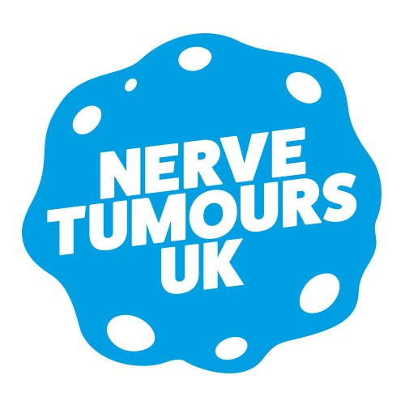

FRIDAY 4 JANUARY 2019

**CHARITY LAUNCHES #ONEMORENURSE CAMPAIGN TO END HEALTH POSTCODE LOTTERY FOR THOSE WITH NERVE TUMOURS**

**Nerve Tumours UK** is launching its **#OneMoreNurse** campaign to end the postcode lottery faced by those with nerve tumours needing access to specialist medical advice and support.

Every day in the UK, a child is born with neurofibromatoses – genetic disorders that have a major impact on the nervous system and lead to tumour formation. Some inherit the condition, others are affected by a random mutation. Nerve tumours can affect any ethnicity, class or sex, and there are currently over 26,000 people in the UK who have one of the neurofibromatoses.

Many health care professionals have little knowledge of nerve tumours and the manifestations of the neurofibromatoses. For example, Neurofibromatosis Type 1 (NF1) predisposes people to many complications which affect most of the body systems. Their occurrence is unpredictable, and complications include disfigurement caused by plexiform neurofibromas, brain tumours, sarcomas, breast cancer epilepsy, scoliosis, rare causes of hypertension. Children with NF1 have an IQ approximately 10 points lower than their peers and problems with working memory and coordination make schooling a real challenge. With approximately 50% of NF1 children developing ADHD and 25% ASD, early diagnosis is crucial.

Some years ago, the charity launched a scheme in partnership with the NHS to provide regional nurse support specialists, but as the attached map shows, this is not yet available throughout the UK. **Nerve Tumours UK** is now seeking to end this postcode lottery by raising additional funds through its **#OneMoreNurse** campaign.

**Michael Fry, Chair of Nerve Tumours UK,** says*, ”Our Support Specialists provide crucial medical and emotional support to patients with NF. But there are large areas of the country that don’t have access to this support – we need at least five more Support Specialists.”*

As **Melanie Gamble**, whose child has NF1, says*, “When our daughter was diagnosed, we were in shock. Fortunately, we were able to speak with a Support Specialist, who explained everything and has been an extraordinary support ever since.”*

**Support the #OneMoreNurse campaign by making a donation at nervetumours.org.uk**

Attached: map of the current UK nurse support specialist provision

For further information and interviews, please contact **Lionel Salama** on **020 3793 2360** or **07957 206 236** or email [**lionel@hope.agency**](mailto:lionel@hope.agency)

continued/…



**NOTES FOR EDITORS**

**Neurofibromatosis Type 1 (NF1)** is a genetic disorder causing usually benign (non-cancerous) tumour growth in the nerve tissue. The “spelling mistake” in the gene is found on chromosome 17 and occurs in 1 in 2,500 of the population. It is therefore more common than Muscular Dystrophy and Huntington’s disease, with approximately 25,000 people in the UK diagnosed with NF1. Half of those affected occur in families with no previous history of NF1.

It causes people to develop multiple nerve tumours: most often on the skin but also on the major nerves and spinal roots. The first sign of NF1 to develop in childhood are flat brown birthmarks called café au lait patches. The significance of these may not be realised and the child not diagnosed until much later.

NF1 predisposes people to many complications which affect most of the body systems. Their occurrence is unpredictable. They include disfigurement caused by plexiform neurofibromas, brain tumours, sarcomas, breast cancer epilepsy, scoliosis, rare causes of hypertension. Children with NF1 have an IQ approximately 10 points lower than their peers. In addition, problems with working memory and coordination make schooling a real challenge. Approximately 50% of NF1 children have ADHD and 25% ASD.

**Neurofibromatosis Type 2 (NF2)** is a rare genetic disorder that is caused by a “spelling mistake” in a single gene on chromosome 22. The misprinted gene will be present at birth, but signs of the condition do not usually appear until the teenage years, twenties or later. NF2 can be passed on from a parent or it can start in a family with no previous history of the disorder. It is rarer than NF1, affecting one in every 30,000 people worldwide.   
People develop nerve tumours, typically in the brain and spine. These tumours are mainly benign, but they can cause hearing loss, deafness, and mobility problems due to the pressure built up on key nerves. NF2 is very different to NF1 in that virtually all people with NF2 will need operations or other treatments for NF2-related brain or spinal cord tumours at some time. A person who has NF2 has a 50% chance of passing on the condition to each of his/her children. NF2 is a variable and unpredictable condition affecting different people in different ways. It is usually diagnosed by MRI scans.

**Schwannomatosis** shares some features of NF2 but not hearing loss. What distinguishes Schwannomatosis from NF2 is that people with this diagnosis rarely, if ever, develop vestibular schwannomas, the hallmark tumour of NF2. It is also very unusual to get any other tumours such as meningioma which are quite common in NF2.  
  
With Schwannomatosis, patients don’t get schwannomas in the skin itself, but these develop on the nerves as they leave the spinal cord, or in the major nerves supplying the arms and legs. There are no eye problems associated with Schwannomatosis.  
  
Unless a person comes from a family with definite Schwannomatosis, the diagnosis is only considered after the more likely possibility of NF2 has been excluded. Patients with suspicious symptoms are usually referred to one of the specialist Neurofibromatosis Centres or reviewed by consultants working within a regional genetics service skilled at differentiating this diagnosis.

**Legius Syndrome** is a condition that is characterised by changes in skin pigmentation (colouring). Almost everyone with Legius Syndrome has multiple café au lait patches on their skin. People with Legius Syndrome also have freckling in the armpit and groins. They tend to have a larger than average head and mild learning difficulties. These characteristics are also seen in NF1.

Legius Syndrome has some similarities with Neurofibromatosis Type 1, but as molecular genetic testing has developed, it became apparent that this is a separate and different condition. The main difference between Legius Syndrome and NF1 is that patients do not develop neurofibromas. Nor do they have any of the health complications that are linked to NF1. Legius Syndrome is a dominant condition which means there is a 50% chance of an affected parent passing it on to each of their children.